# Chapter 8

**User Manual**

Appendices are provided to give supplementary information, which is included in the main text and images which helps in understanding the flow of application.

**Android Application**

**8.1 Splash Screen:**

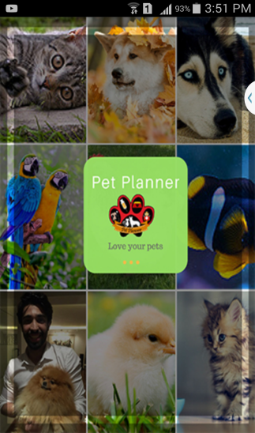

Splash screen will be displayed for few seconds.

**8.2 Login**

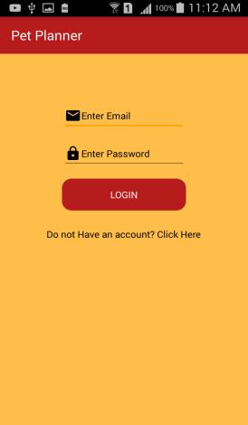

User will enter valid email and password to login into the application.

**8.3 Registration**

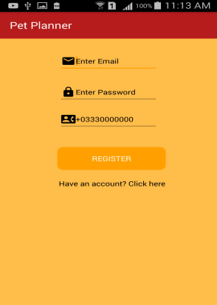

If user is new then he/she will register into the system.

**8.4 Home Page**

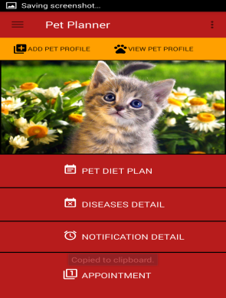

After the successful login user is able to add pet profile, view pet

Profile, generate diet plan, view diseases details, generate alarm notifications and take appointment.

**8.5 Diet Plan**

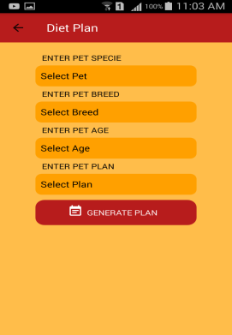

User can select pet specie, breed, age and plan to generate and download diet plan.

* 1. **Diseases Details**

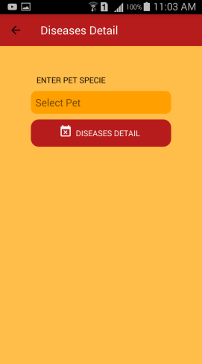

User can select pet specie to view pet diseases details.

* 1. **Notification Details**

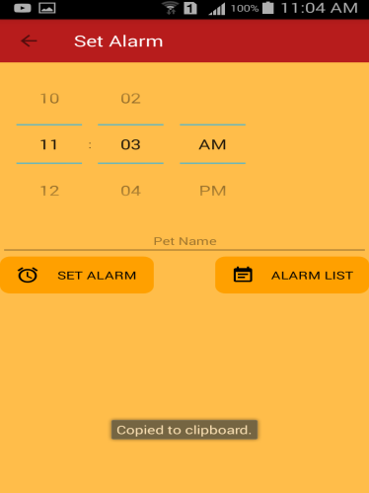

User can set alarm so that his pet could be feed.

* 1. **Appointment**

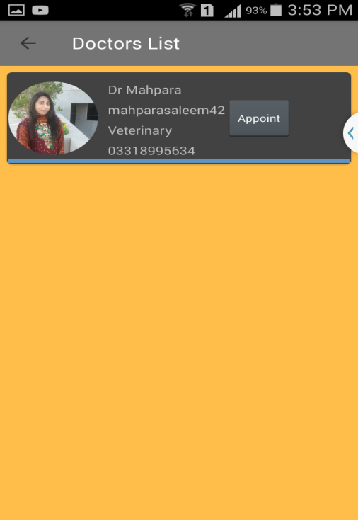

User can take appointment by clicking on Appoint button.

* 1. **Add Pet Profile**

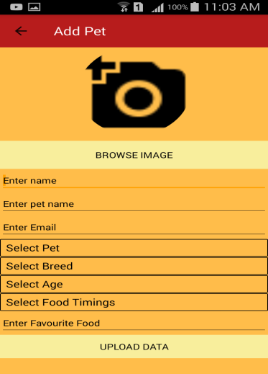

User can add pet details by filling all the fields.

* 1. **View Pet Profile**

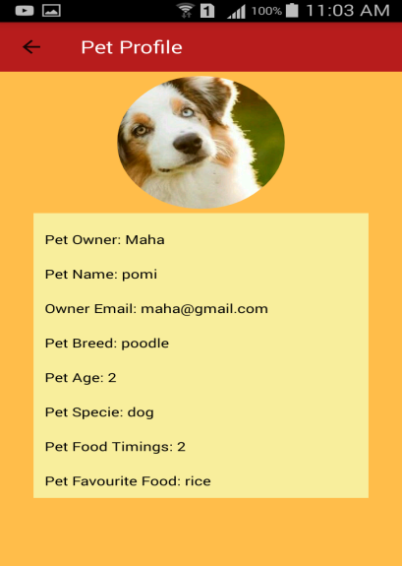

By clicking on view pet profile user is able to view pet profile.

* 1. **Add as a Doctor**

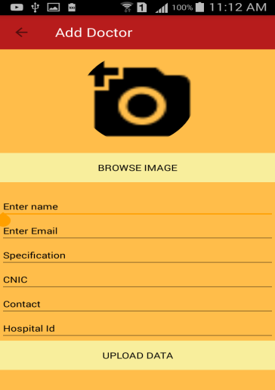

User is a admin then he can register the doctor entering the correct hospital id assigned by the hospital to the doctor.

# Appendices-B

**B-Web Application**

1. Home Button

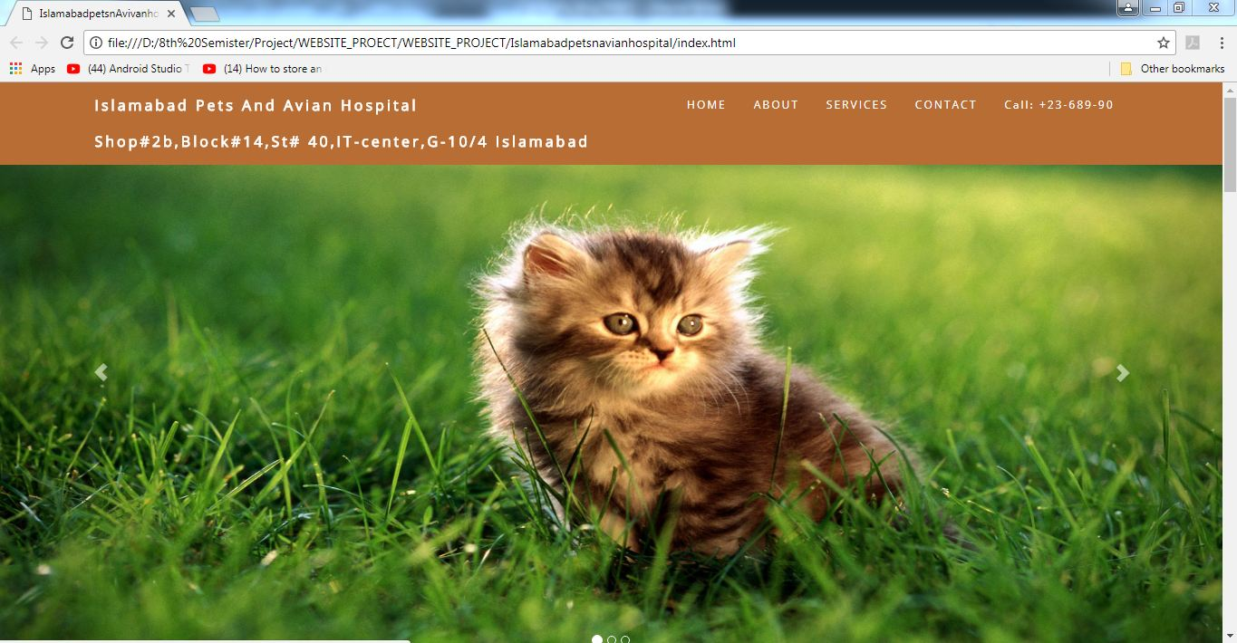

From Index page by clicking HOME will navigate to HOME screen

1. About us

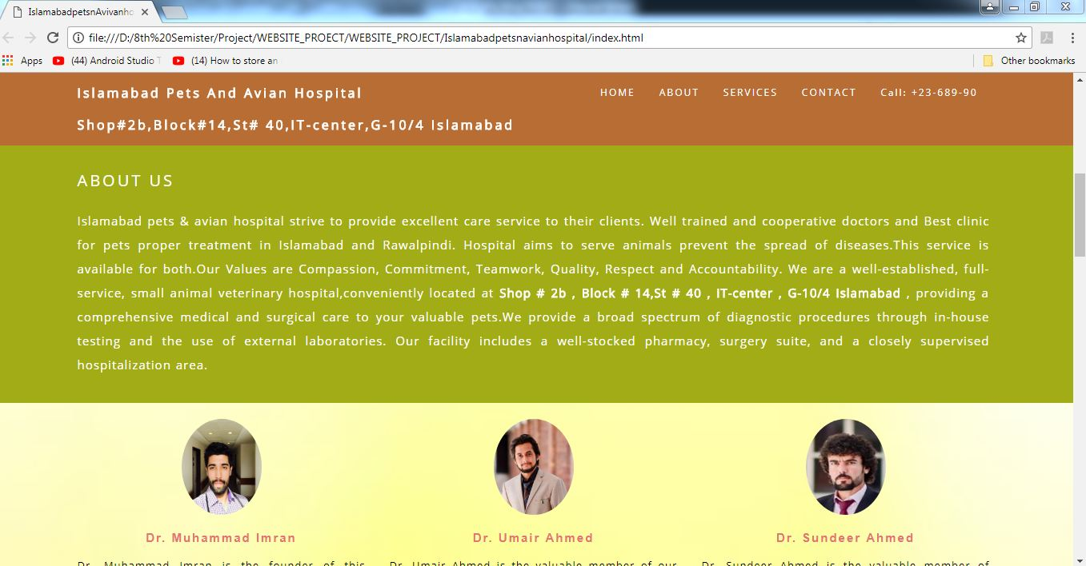

On selecting ABOUT from menu we navigate to ABOUT US screen

1. Services Details

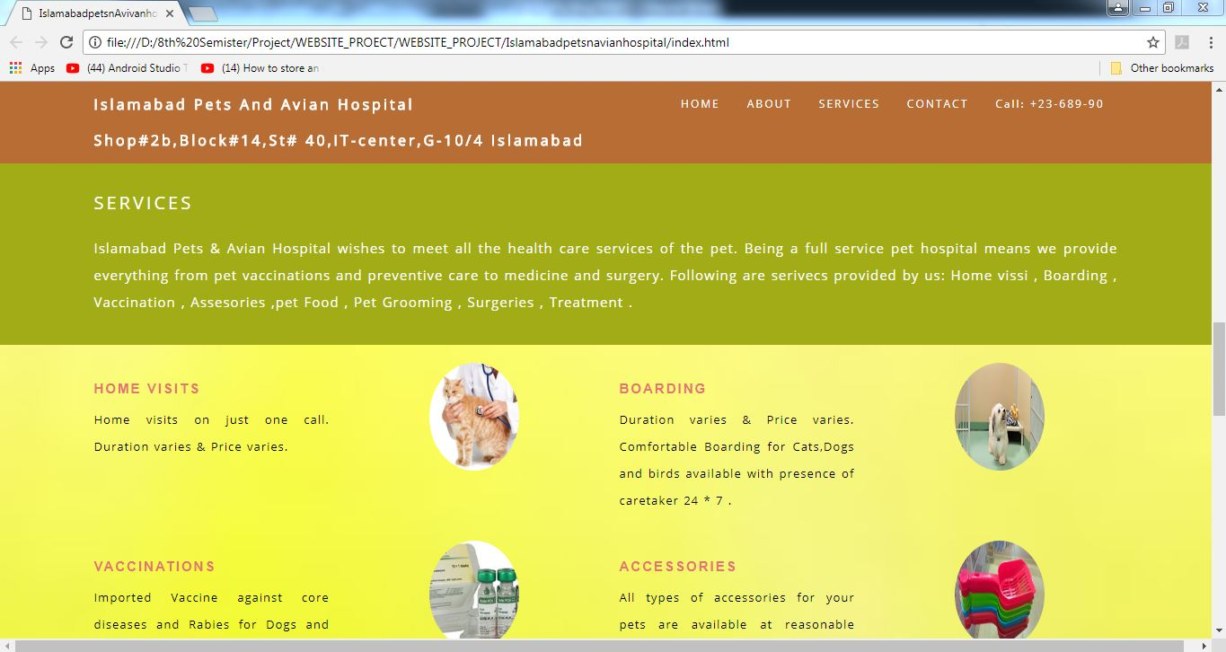

On selecting SERVICES from menu we navigate to SERVICES Screen

1. Contact Us

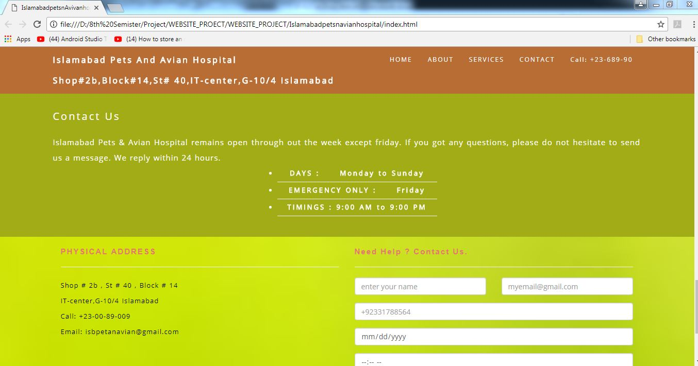

On selecting CONTACT from menu we navigate to CONTACT Screen.

1. Appointment

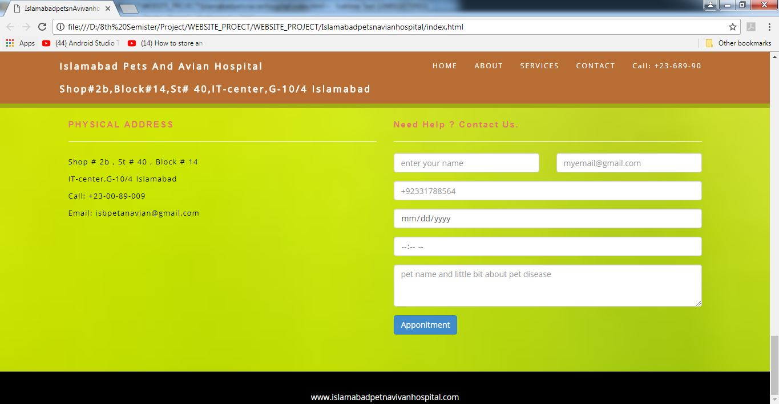

User can take APPOINTMENT by full filling the entire field.